# Central Tendency White Paper Requirements Specification

## Scripts for Output defined in: Figure 7.1 Box Plot – Observed Values of xxx Over Time

### Script Specification

#### Specific Output Requirements

* Generates a box plot of AVAL by AVISITN and TRTPN. See domain variations in Usage Requirements, below
* Basic script functionality (user options)
* ***data display features***
* notched box plot
* outliers:
* IQR outliers as boxes, and
* reference range outliers as red dots
* reference ranges - options to draw reference lines for various scenarios (based on values found in data)
* uniform – draw uniform
* not uniform – draw narrow
* all
* none
* numeric value
* ***User variability***
* location and name of each input data sets
* output location (user-specified path)
* parameterize core variables required for analysis & display:
* AVAL (measured outcome)
* ANRLO (lower limit of reference range)
* ANRHI (upper limit of reference range)
* SAFFL (population flag)
* ANL01FL (analysis flag)
* ***basic readability features***
* maximum number of boxes to display on a page (basic paging control)
* on/off jitter option (to reduce overlap of reference range outliers)
* Restrictions
* Footnote:
* Box plot type=schematic, the box shows median, interquartile range (IQR, edge of the bar), min and max within 1.5 IQR below 25% and above 75% (ends of the whisker). Values outside the 1.5 IQR below 25% and above 75% are shown as outliers. Means plotted as different symbols by treatments

#### General Output and Formatting Requirements

NOTE: These might or might not apply to the specific output or feature of the script.

***[DDT] Suggestion:***

* **Move all general requirements to a "CSS Standard Analyses General Output and Formatting Requirements" document.** [**This looks like a good starting point.**](http://www.phusewiki.org/wiki/index.php?title=Scriptathon_targets_as_of_January_4_2015)
* **Move all "Central Tendency" requirements to a "Output and Formatting Requirements" section of the CT white paper**
* **Keep only target-specific requirements in this document**
* *Move to new Project 8 doc at same level as the white papers:* ***"CSS Standard Analyses General Output and Formatting Requirements"***
* The page margins used in this document mirror the margins required for US regulatory submissions. TFL fits within 9.25” x 6” common text area.
* This document contains generic titles and footnotes to aid review.
* Titles must be centered.
* Footnotes must be left justified
* Placeholders for the program, output, date generated, and source data footnotes do not need to be displayed for each shell but will be produced for each TFL consistent with the standard macro output.
* P-values should follow the formats below (these guidelines align with medical journal requirements):
* For p > 0.1, report the p-value to 2 decimal places
* For 0.1 > p > 0.001, report the p-value to 3 decimal places
* For p < 0.001, report p < 0.001.
* Decimal places for continuous data summaries should follow these guidelines:
* mean and estimates of precision (e.g., variance, SD, SE, Confidence Intervals) have 1 more decimal place than the collected data
* distributional parameters (eg, Q1, Q3) also have 1 more decimal place than the collected data
* present Minimum and Maximum to the same decimal places as collected
* percentages have at least one decimal place
* All tables summarizing baseline data must include a “total” column for studies with more than 1 arm.

### Usage Requirements

#### Required Input

* Dataset-1: ADSL
* Variables: STUDYID, USUBJID, SAFFL, TRT01P, TRT01PN

##### Vital Signs Domain

* Dataset-2: ADVS
* Variables: STUDYID, USUBJID, SAFFL, ANL01FL, TRTP, TRTPN, PARAM, PARAMCD, AVAL, ANRLO, ANRHI, AVISIT, AVISITN, ATPT, ATPTN
* Record selection: SAFFL='Y' and ANL01FL='Y'

##### Laboratory Domain

* Dataset-2: ADLBC or ADLBH or ADLBHY?
* Variables: STUDYID, USUBJID, SAFFL, ANL01FL, TRTP, TRTPN, PARAM, PARAMCD, AVAL, A1LO, A1HI, AVISIT, AVISITN~~, ATPT, ATPTN~~
* Record selection: SAFFL='Y' and ANL01FL='Y'

##### ECG Domain

* Dataset-2: ???
* Variables: ???
* Record selection: ???

#### Macros

* Requires the PhUSE/CSS macro library:   
   <https://github.com/phuse-org/phuse-scripts/tree/master/whitepapers/utilities>
* User must ensure that SAS can find PhUSE/CSS macros in the SASAUTOS path

### Test Data

* Data sets from <https://github.com/phuse-org/phuse-scripts/tree/master/scriptathon2014/data>
* ADSL – Subject-level data
* Domain data
  + Vital Signs Domain
  + ADVS – Vital signs
  + ADLBC, ADLBH, ADLBHY – Laboratory measures
  + ??? – ECG measures

### Sample Output

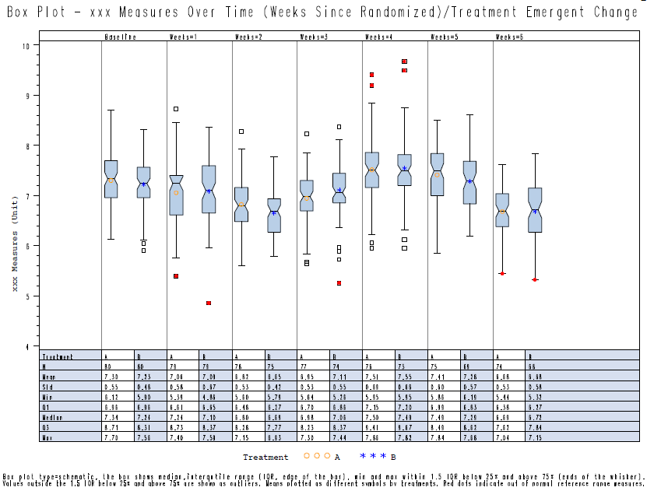

### Reference Documents:

White paper: <http://www.phusewiki.org/wiki/images/4/48/CSS_WhitePaper_CentralTendency_v1.0.pdf>

Programming Guidelines: <http://www.phusewiki.org/wiki/index.php?title=WG5_P02_Programming_Guidelines>